**Group 7: Entrepreneurial Finance and Accounting**

1. **INTRODUCTION**

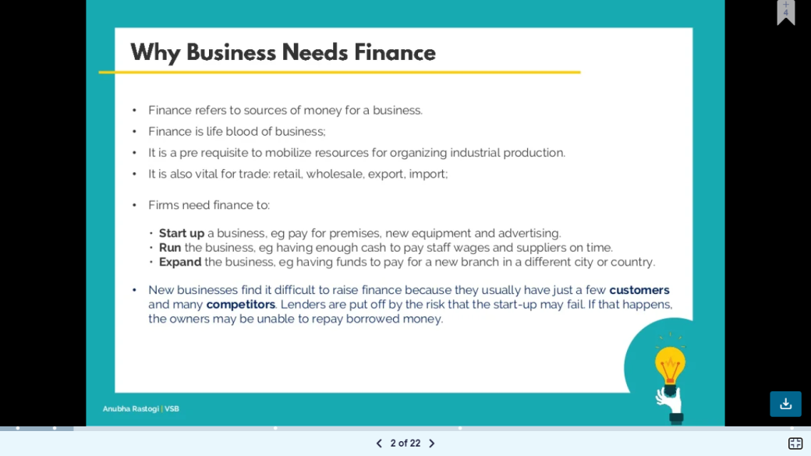**Introduction to Entrepreneurial Finance**

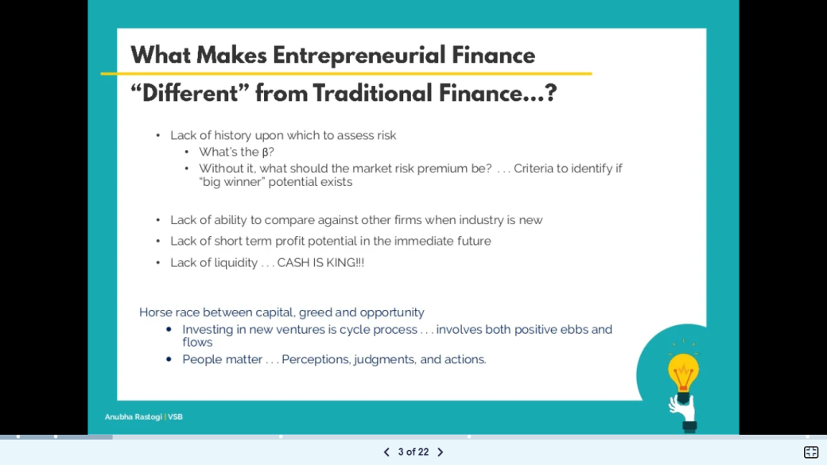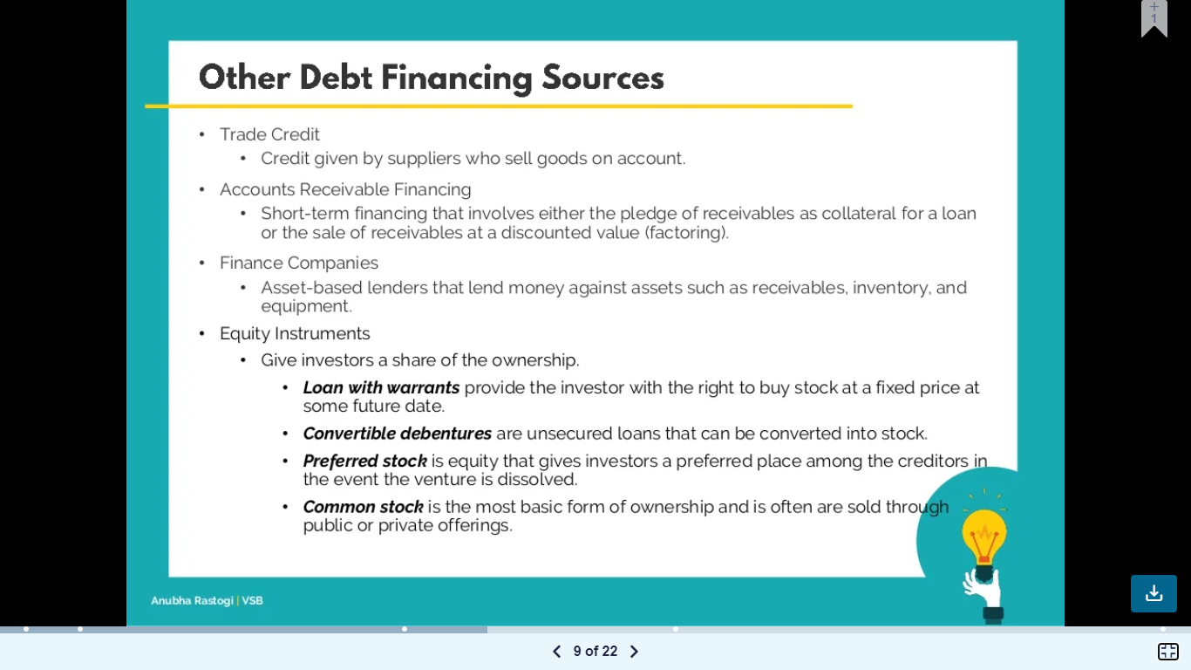

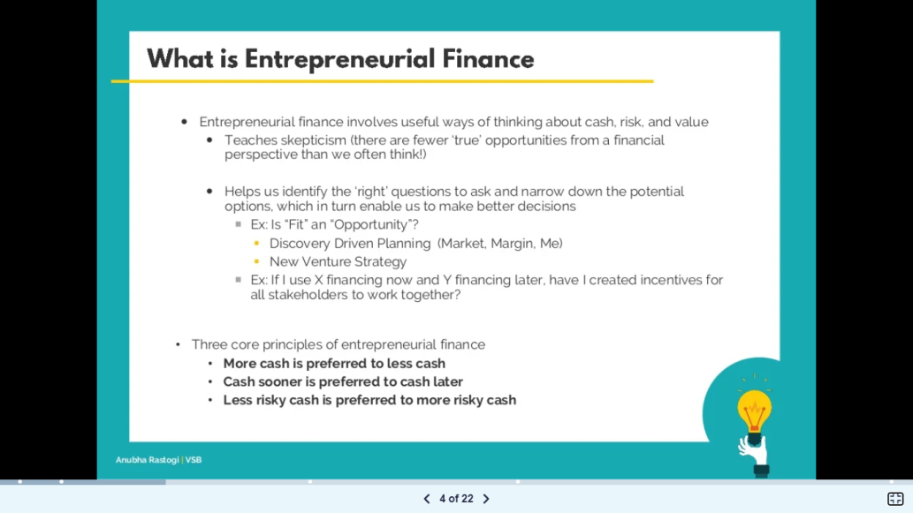

**Introduction to Accounting**

***Accounting is the language of business. It is the system of recording, summarizing, and analyzing an economic entity's financial transactions.*** Effectively communicating this information is key to the success of every business. Those who rely on financial information include internal users, such as a company's managers and employees, and external users, such as banks, investors, governmental agencies, financial analysts, and labor unions. These users depend upon data supplied by accountants to answer the following types of questions:

• Is the company profitable?

• Is there enough cash to meet payroll needs?

• How much debt does the company have?

• How does the company's net income compare to its budget?

• What is the balance owed by customers?

• Has the company consistently paid cash dividends?

• How much income does each division generate?

• Should the company invest money to expand?

*Accountants must present an organization's financial information in clear, concise reports that help make questions like these easy to answer.* ***The most common accounting reports are called financial statements.***

1. **Overview of Entrepreneurial Finance and Accounting Strategies**

**ENTREPRENEUR IN ACTION**

Ted Herget and Gearhead Outfitters

Gearhead Outfitters, founded by Ted Herget in 1997 in Jonesboro, Arkansas, is a retail chain that sells outdoor gear for men, women, and children. The company’s inventory includes clothing, footwear for hiking and running, camping gear, backpacks, and accessories. Herget fell in love with the outdoor lifestyle while working as a ski instructor in Colorado and wanted to bring that feeling back home to Arkansas. And so, Gearhead was born in a small downtown location in Jonesboro. The company has had great success over the years, expanding to numerous locations in Herget’s home state, as well as to locations in Louisiana, Oklahoma, and Missouri.

While Herget knew his industry when starting Gearhead, like many entrepreneurs he faced regulatory and financial issues that were new to him. Several of these issues were related to accounting and the wealth of decision-making information that accounting systems provide. For example, measuring revenue and expenses, providing information about cash flow to potential lenders, analyzing whether profit and positive cash flow is sustainable to allow for expansion, and managing inventory levels. Accounting, or the preparation of financial statements (balance sheet, income statement, and statement of cash flows), provides the mechanism for business owners such as Herget to make fundamentally sound business decisions.

**Entrepreneurial Funding across the Company Lifecycle**

An entrepreneur may pursue one or more different types of funding. Identifying the lifecycle stage of the business venture can help entrepreneurs decide which funding opportunities are most appropriate for their situation.

From inception through successful operations, a business’s funding grows generally through three stages: seed stage, early stage, and maturity (Figure 9.2). A seed-stage company is the earliest point in its lifecycle. It is based on a founder’s idea for a new product or service. Nurtured correctly, it will eventually grow into an operational business, much as an acorn can grow into a mighty oak—hence the name “seed” stage. Typically, ventures at this stage are not yet generating revenue, and the founders haven’t yet converted their idea into a saleable product. The personal savings of the founder, plus perhaps a few small investments from family members, usually constitute the initial funding of companies at the seed stage. Before an outsider will invest in a business, they will typically expect an entrepreneur to have exhausted what is referred to as F&F financing—friends and family financing—to reduce risk and instill confidence in the business’s potential success.

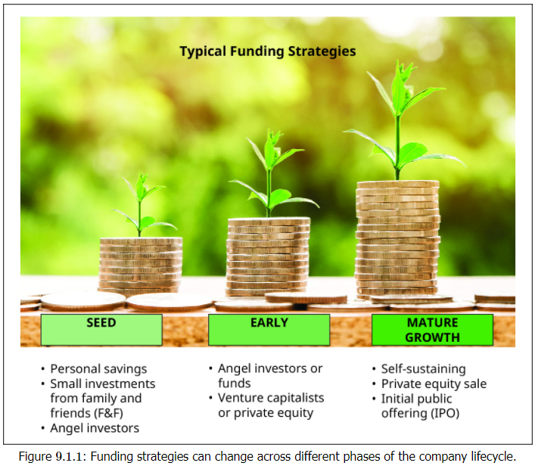

After investments from close personal sources, the business idea may begin to build traction and attract the attention of an angel investor. **Angel investors** are wealthy, private individuals seeking investment options with a greater potential return than is traditionally expected on publicly traded stocks, albeit with much greater risk. For that reason, they must be investors accredited by the federal Securities and Exchange Commission (SEC) and they must meet a net worth or income test. Nonaccredited investors are allowed in certain limited circumstances to invest in security-based crowdfunding for startup companies. Among the investment opportunities angel investors look at are startup and early stage companies. Angel investors and funds have grown rapidly in the past ten years, and angel groups exist in every state.

An **early stage** company has begun development of its product. It may be a technical proof of concept that still requires adjustments before it is customer ready. It may also be a first-generation model of the product that is securing some sales but requires modifications for large-scale production and manufacturing. At this stage, the company’s investors may now include a few outsider investors, including venture capitalists. A **venture capitalist** is an individual or investment firm that specializes in funding early stage companies. Venture capitalists differ from angel investors in two ways. First, a venture capital firm typically operates as a full-time active investment business, whereas an angel investor may be a retired executive or business owner with significant savings to invest. Additionally, venture capital firms operate at a higher level of sophistication, often specializing in certain industries and with the ability to leverage industry expertise to invest with more know-how. Typically, venture capitalists will invest higher amounts than angel investors, although this trend may be shifting as larger angel groups and “super angels” begin to invest in venture rounds.

Companies in the **mature stage** have reached commercial viability. They are operating in the manner described in the business plan: providing value to customers, generating sales, and collecting customer payments in a timely manner. Companies at this stage should be self-sufficient, requiring little to no outside investment to maintain current operations. For a product company, this means manufacturing a product at scale, that is, in very large volumes. For a software company or app provider, this means generating sales of the software or subscriptions under an SaaS model (Software as a Service) and possibly securing advertising revenue from access to the user base.

An **initial public offering (IPO)** occurs the first time a company offers ownership shares for sale on a public stock exchange, such as the New York Stock Exchange. Before a company executes an IPO, it is considered to be privately held, usually by its founders and other private investors. Once the shares are available to the general public through a stock exchange, the company is considered to be publicly held. This process typically involves an investment banking firm that will guide the company. Investment bankers will solicit institutional investors, such as State Street or Goldman Sachs, which will in turn sell those shares to individual investors. The investment banking firm typically takes a percentage of the funds raised as its fee. The benefit of an IPO is that the company gains access to a massive audience of potential investors. The downside is that the owners give up more ownership in the business and are also subject to many costly regulatory requirements. The IPO process is highly regulated by the SEC, which requires companies to provide comprehensive information up front to potential investors before completing the IPO. These publicly traded companies must also publish quarterly financial statements, which are required to be audited by an independent accounting firm. Although there are benefits to an IPO for later-stage companies, it can be very costly both at the start and on an ongoing basis. Another risk is that if the company does not meet investors’ expectations, the value of the company can decline, which can hinder its future growth options.

**Types of Financing**

* Debt financing
* Equity Financing

**Debt financing** is the process of borrowing funds from another party. Ultimately, this money must be repaid to the lender, usually with interest (the fee for borrowing someone else’s money). Debt financing may be secured from many sources: banks, credit cards, or family and friends, to name a few. The maturity date of the debt (when it must be repaid in full), the payment amounts and schedule over the period from securement to maturity, and the interest rate can vary widely among loans and sources. You should weigh all of these elements when considering financing.

The **advantage of debt financing** is that the debtor pays back a specific amount. When repaid, the creditor releases all claims to its ownership in the business. The disadvantage is that repayment of the loan typically begins immediately or after a short grace period, so the startup is faced with a fairly quick cash outflow requirement, which can be challenging.

In terms of investment opportunities, equity investments are those that involve purchasing an ownership stake in a company, usually through shares of stock in a corporation. Unlike debts that will be repaid and thus provide closure to the investment, equity financing is financing provided in exchange for part ownership in the business. Like debt financing, **equity financing** can come from many different sources, including friends and family, or more sophisticated investors. You may have seen this type of financing on the TV show Shark Tank. Contestants on the series pitch a new business idea in order to raise money to start or expand their business. If the “sharks” (investors) want to invest in the idea, they will make an offer in exchange for an ownership stake. For example, they might offer to give the entrepreneur $200,000 for a return of 40 percent ownership of the business.

The **advantage of equity financing** is that there is no immediate cash flow requirement to repay the funds, as there is with debt financing. The drawback of equity financing is that the investor in our example is entitled to 40 percent of the profits for all future years unless the business owner repurchases the ownership interest, typically at a much higher valuation—an estimate of worth, usually described in relation to the price an investor would pay to acquire the entire company.

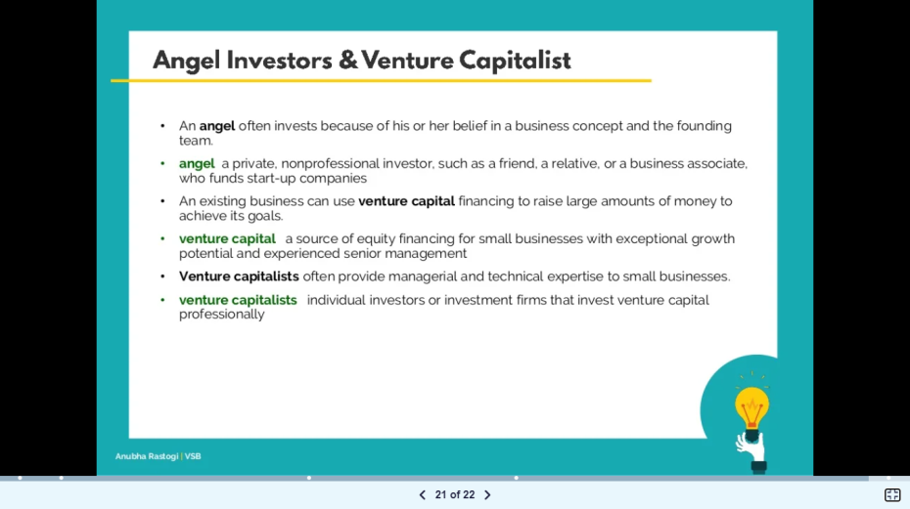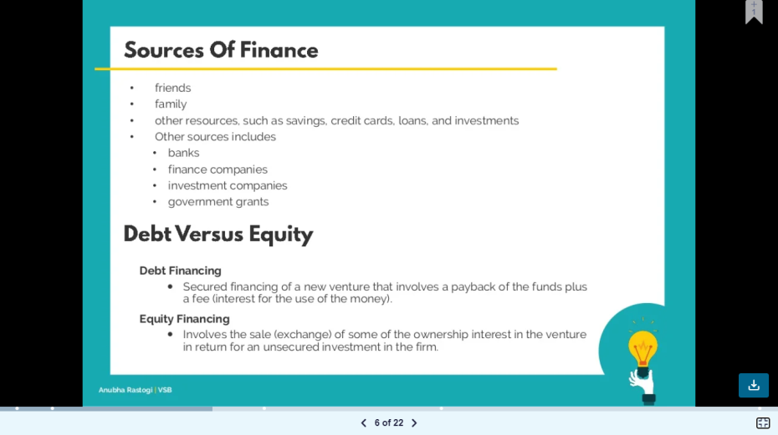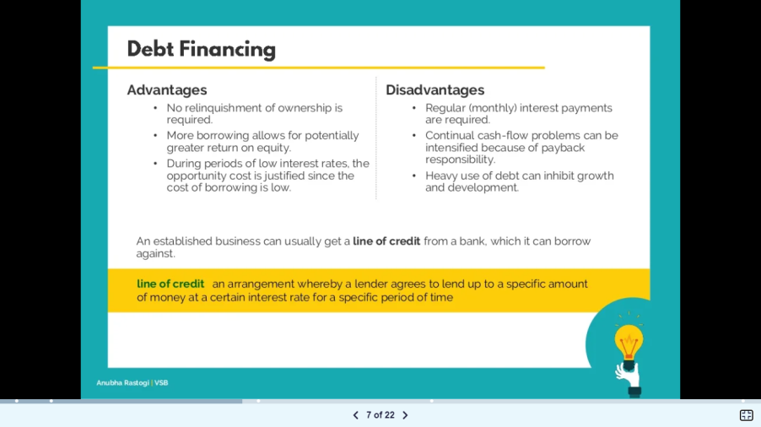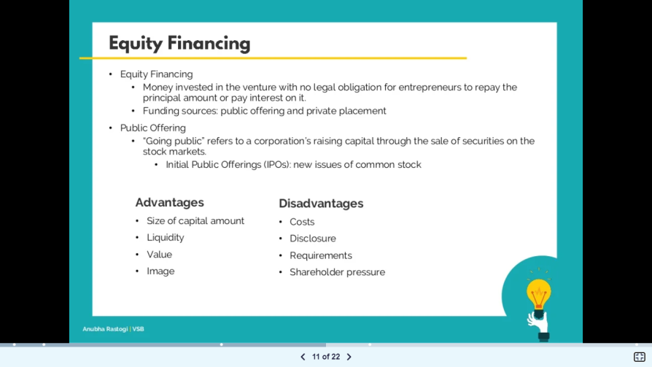

**Five Essential Finance And Accounting Strategies For Small Businesses**

Irrespective of your business profile, you can manage your company’s finances using some simple accounting strategies. One of the areas of work that you need to master from the very beginning of your business is finances and accounts. The right time to manage all your business finances is from the start of this journey. A crucial factor in the constant growth of small businesses around the globe is a well-planned and implemented accounting strategy. As a business owner, you must track your revenues, expenditures and profits systematically right from the start of your business.

To avoid running into issues such as improper taxation details or chaotic bookkeeping, it is wise to plan your accounting strategy well beforehand. Here are some finance and accounting strategies for small businesses that can help you to manage your work operations and plan ahead of time to achieve your business goals.

**1. Separate business and personal expenses:**One of the most common mistakes that small businesses commit is mixing up their personal and professional expenditures. When you start a new business, it becomes mandatory to have a separate account for your business-related finances. Having an exclusive business account streamlines the entire business transaction and makes it easy to maintain all the necessary records.It is always advisable to avoid making any personal payment via your business account or vice versa. Maintaining an account exclusively for business investments is the first step toward a successful accounting strategy.

**2. Consider hiring a professional:**One of the key factors behind well-maintained business finances and accounting is an experienced accountant. No matter how new you are in the business, you should seriously consider hiring a professional to look after your accounts. Bookkeeping is a crucial part of any business organization and it needs to be done expertly. Seek an accountant who can help you in calculating your money, keeping track of your expenses and designing a feasible financial plan. Remember, the success of your business depends largely on accurate financial managing strategies.

3. **Use appropriate accounting software:** The advancement in technology has made operational accounting quite organized. There is software available in the market that allows you to streamline the entire accounting process. Appropriate accounting software can track your income and expenses, categorize them accordingly, send and pay invoices and generate reports periodically. You need to choose the most appropriate one that resonates well with your business objectives and has a time-saving user-friendly interface. Go for software that can help you accurately and efficiently in maintaining your business finances.

4. **Keep track of business cash flow:** It is very important to minutely monitor and keep a track of the cash flow within an organization. You need to document all your business transactions very precisely. Documentation helps you in remembering all the business-related expenditures. One way to track the cash flow is to categorize each expense and assign it a label. Always try to store all the data related to your expenditure in the system digitally. You can even add it to your accounting software for better tracking and accessibility.

**5. Back up your account records:**Machines are, after all, machines and not humans, so there is always a chance of unpredictable system crashes, data mishandling or any other mishap that may occur to your stored data. Therefore, it becomes very apparent that you must always back up your bookkeeping files and essential accounting data to ensure no crucial information related to your finances is lost during such a technical glitch. To be on the safer side, always have at least two to three copies of your bookkeeping data.

Finance is the vertebrae of any business organization. Irrespective of your business profile, you must try to bring the above-mentioned strategies into practice to avoid any discrepancies later. Accounting for small businesses is not very complex, so if you follow the correct steps right from the beginning, things will be much easier for you later. Remember, the right business finance and accounting strategy can help you withstand any unforeseen circumstances later in the business.

**5 Must-Know Finance and Accounting Strategies for Small Businesses During Uncertain Times**

Economies and markets throughout the world are ever-changing, and business owners must be prepared to face unforeseen circumstances that impact their companies in unexpected ways. Whether the cause is an economic downturn or a global pandemic, all businesses must learn [how to adapt to uncertain times](https://www.europeanbusinessreview.com/3-ways-businesses-need-to-adapt-to-survive-covid-19/). For small businesses, adjusting to a changing marketplace can be particularly challenging.

It is during these times that small businesses must develop and execute solid financial strategies. After all, having a robust cash flow system is essential to maximizing revenue and paying operating expenses. To help small businesses forge ahead during these uncertain times, here are five must-know finance and accounting strategies to employ.

**1. Improve the cash flow of your business**

Cash flow is the lifeline of a business, so every aspect of it must be managed with care. What good is it for a company to generate more revenue if its expenses are out of control?

Here are some practical tips for small businesses to improve cash flow:

**Streamline invoicing**

Invoices make it possible for clients to pay their bills, and providing a smooth checkout experience is one of the most important parts of [migrating more of your business processes online](https://blog.powr.io/how-to-quickly-migrate-your-business-online-without-breaking-the-bank).

Customers can sometimes forget to pay their business invoices, but this doesn’t mean that businesses shouldn’t pursue all payments in a timely manner. You should look for invoicing software that [comes with crucial features](https://www.freshbooks.com/invoice-templates/google-docs) like automatic billing for repeat customers to make sure you are getting paid on time.

**Increase the prices of goods and services**

Periodically, small business owners should assess their rates to determine if they are too low. Businesses that sell themselves short can come off as low value or less qualified than competitors. Do some market research to evaluate how your prices compare to other industry players.

**Offer new products or services**

Business owners must constantly be on the lookout for new and [innovative ways to monetize their businesses](https://www.europeanbusinessreview.com/unique-ways-to-monetize-your-blog/). Adding new products to the mix can breathe life into a stagnant company and attract new customers. Adding content like a blog or podcast can also entice potential customers and get them to your website.

**Evaluate operating expenses**

Unnecessary expenditures can drain a company’s finances. It is essential for small business owners to assess expenses each quarter and reduce (or eliminate) them as necessary.

Some expenses that can wreak havoc on a company’s bottom line include:

* Coffee, snacks, and food for employees
* Subscriptions services
* Late payments of credit cards and other bills
* Trade show booths and attendance
* Postage
* Ineffective advertising
* Inefficient employees

**2. Track all expenses**

It is essential that small businesses pay close attention to every expense. Taking this action can prevent wasteful spending before it gets out of hand, as well as help identify theft and fraudulent financial activities.

There are plenty of easy ways for businesses to stay on top of expenses, such as keeping receipts for business expenses and scanning them onto digital software that is safe and secure. You can create digital storage categories for each expense type as well.

If possible, pay for expenses with business credit cards. This can [reduce the paperwork](https://www.allbusiness.com/what-are-the-advantages-of-business-credit-cards-11197-1.html) that small businesses have to keep track of. In addition, you can earn cash back rewards for purchases with credit cards.

**3. Use finance and accounting automation tools**

Manual accounting processes such as data entry and spreadsheets often increase the time it takes for businesses to get paid. In contrast, finance and accounting automation tools make the process of managing cash flow efficient, fast, and accurate.

When selecting cash flow automation tools, look for software or apps that are user-friendly. That way, employees won’t have to spend too much time learning how to use new software. It should also be easy on the customer side so as not to slow down any checkout processes or slow down your website.

You should also consider investing in cloud-based solutions. Cloud-based accounting solutions offer faster billing services and real-time data for analysis. Quality accounting tools also offer enhanced security that provides protection against malware and data theft.

According to web developer Alex Williams of Hosting Data, [cloud-based technology is beneficial for scaling](https://hostingdata.co.uk/#:~:text=you%20end%20up%20with%20very%20quick%20loading%20times) an online business:

“You end up with very quick loading times and lots of flexibility in climbing up or down the scale ladder,” says WIlliams. “This goes for space. Upgrades are immediate, which is why cloud hosting has boomed in popularity recently.”

Scalable software may have higher upfront costs, but they can serve as reliable accounting solutions for years to come. Some top examples of cloud-based financial automation tools for small businesses are:

* Intuit Quickbooks
* FreshBooks
* Xero
* Wave Accounting
* Sage Business Cloud Accounting

**4. Prepare a cash flow forecast**

Quite simply, a cash flow forecast is a plan that estimates the future revenue and expenses of a business. Typically, there are three types of cash flow forecasts, short-term (30 days or less), medium-term (one month to a year), and long-term (one to five years).

A cash flow forecast gives business owners a glimpse of their company’s financial position. It helps them to make informed financial decisions based on current assets and future projections. They can determine whether they have more cash coming into the business (positive cash flow) than going out of the business (negative cash flow).

To prepare a cash flow forecast:

* **Determine the objectives.** Examples include debt reduction, short-term liquidity planning, and growth planning.
* **Select a forecasting period.** For example, you may need short-period, medium-period, long-period, or mixed-period.
* **Choose a forecasting method.**Consider [indirect vs. direct forecasting](https://www.educba.com/direct-vs-indirect-cash-flow-methods/) methods.
* **Gather relevant data.** You will need the appropriate financial records and other information to forecast properly.

**5. Hire a professional accountant or bookkeeper**

Growing a business and managing its finances may be too much for one person (or even a small team) to handle. It is a good idea to offload accounting responsibilities to a professional even if it is on a part-time basis. Getting help from an accountant or bookkeeper can free up time for other activities that help your business growth such as[updating your marketing strategies](https://www.europeanbusinessreview.com/8-best-mobile-marketing-campaigns-examples-to-learn-from/) and nurturing client relationships.

**Conclusion**

Without a strong financial position, a small business may not survive – and certainly won’t reach its full potential. Proven finance and accounting practices can give businesses tools to [handle financial emergencies](https://www.europeanbusinessreview.com/what-can-i-do-if-i-need-money-now/) and succeed in tough markets. By implementing these strategies, any company in any industry can set themselves up for success.

1. **Special Funding Strategies**

**Charitable organizations**, or certain nonprofit companies, are often founded for altruistic purposes, such as advancing the arts, education, and science; protecting the natural environment; providing disaster relief; and defending human rights (Table 9.2.1).



These goals supersede the profit motive that a traditional company would have. As a result, the funding strategies of these enterprises often differ quite dramatically from those of standard for-profit businesses. Without the emphasis on profit, it can be difficult to provide for the cost of ongoing operations. Thus, these organizations must develop a **sustainable strategy**—one that can maintain the organization’s financial stability.

Consider a museum. What is its purpose? Traditional companies provide a product or service to their customers in exchange for payment, and typically fill a need their customers have. A grocery store sells food because human beings need to eat food to survive. Although viewing paintings and sculptures is not a physical requirement for life, this experience arguably enriches our lives and helps educate and shape our society. That is why museums are founded. Consider the original mission statement of the Metropolitan Museum of Art (commonly known as the “Met”) in New York City (Figure 9.2.1 ).7

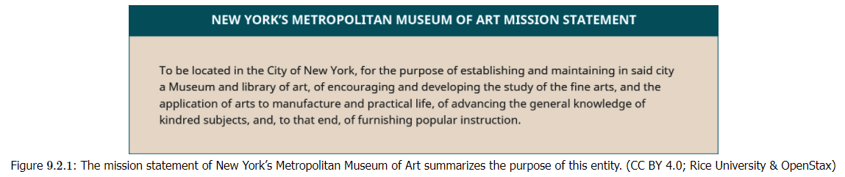

This is a different goal than that of most small businesses (providing a product or service in exchange for a profit) and, as a result, requires different financing strategies, such as a combination of **program services**, **donations**, and **grants**.

* **Program services** are the basic offerings that a nonprofit organization provides that result in revenue, although not typically enough to cover the overall cost of running the organization. These services most closely resemble the customer interactions of a traditional business. The organization provides a product or service in exchange for a customer’s money.

In our museum example, program services could take a few different forms. First, the museum likely charges a fee for admission to view the artwork and artifacts. The individual ticket price multiplied by the number of museum visitors equals the museum’s ticket revenue. An established museum will have a good sense of how many visitors it has on average and can use these data to create a budget.

* **Donations** One benefit to a business with a charitable mission is inherent public support, which can foster community involvement above and beyond patronage. For nonprofits, this can translate into a willingness to donate money to the organization. A donation is a financial gift with no expectation of repayment or receiving anything in return. A traditional business must provide something valuable to create a customer exchange: Their customers demand value in exchange for their hard-earned money.
* **Grants** Another source of funding for nonprofit organizations is grants. A **grant** is a financial gift given for a specific purpose by a government agency or a charitable organization such as the Bill and Melinda Gates Foundation. Like a donation, a grant does not have to be repaid. Unlike with donations, both nonprofit and for-profit organizations can compete for grants. Whereas donations are typically given without restriction to offset the general operating expenses of the organization, grants often specify how the funds are to be used. Most grant-providing entities have an agenda or purpose behind their funding. For example, the National Institutes of Health (NIH) provides grants “to support the advancement of the NIH mission to enhance health, extend healthy lives, and reduce the burdens of illness and disability.”9 This federal organization invests over $32 billion annually for medical research.

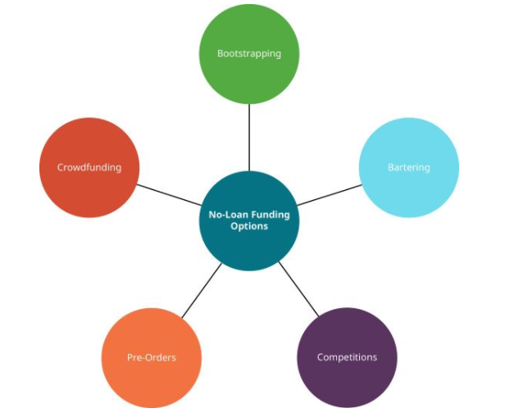

**No-Loan Finance Strategies**

As you’ve learned, many startups come into being through the extensive use of debt. Although borrowing is a legitimate source of funding, it can be risky, especially if the entrepreneur is personally responsible for repayment. In practice, some entrepreneurs max out credit cards, take out home-equity loans against their primary residences, or secure other high-interest personal loans. If the entrepreneur fails to repay the loans, the result can be repossession of equipment, home foreclosure, and other legal action.

**Crowdfunding**

This venture was originally funded by contributions through Indiegogo and Kickstarter. These websites are a form of **crowdfunding**, which involves collecting small sums of money from a large number of people. The people who contribute money are typically referred to as backers because they are backing the project or supporting the business idea.

Browsing these crowdfunding websites, you will see many different kinds of ventures seeking financial backing—from creating new board games to opening donut cafes. Each project identifies an overall specific funding goal in terms of a dollar amount. Some crowdfunding websites, such as Kickstarter, implement an “all or nothing” model in which projects do not receive any funds unless their overall funding goal is met. The amount can be exceeded, but if it is not met, the project receives nothing. For an entrepreneur utilizing this resource, selecting an attainable funding goal must be a core part of their strategy. The funding goal must also be appropriate to the scale of the project.

The **advantage of crowdfunding** is that the business receives cash up front to launch. The down side is that the reward requires a future payment to the backers. This payment may be in the form of branded merchandise, meals, or even events or travel, so it is important for entrepreneurs to set aside part of the investment money to fund the rewards. Depending solely on generating the reward funds out of future sales is a risk that might result in upsetting the very fans who made the business possible. Since crowdfunding is managed online, another risk is upsetting the project’s vocal supporters. Crowdfunding usually provides only a “kick start” for a startup, so most seed-stage companies will need additional funding from other sources to get to their first commercial launch.

**Bartering**

Bartering is a system of exchanging goods or services for other goods or services instead of for money. Let’s consider the case of Shanti, a website designer who wants to start a business. She may want to have her business formally incorporated or may require other legal help, such as review of standard contracts. Hiring a lawyer outright for these services can be costly, but what if the lawyer needed something that a website designer could provide?

Whether the lawyer has just started his own business or has been established for several years, he may need a website created or have an old website redesigned and updated. This website overhaul could prove costly for the lawyer. But what if there were a way that both the lawyer and the web designer could get what they wanted with a resulting net cost of zero dollars? Bartering can achieve this. It should be noted that there are accounting and tax implications involved with bartering that can prevent a net zero offset of costs.

In a barter scenario, Shanti could create a website for the lawyer at the expense only of her time, which in the startup phase is often more abundant than actual cash. The lawyer could provide incorporation services or contract review in exchange, requiring no cash outlay. For many entrepreneurs, this type of exchange is appealing and enables them to meet business needs at a lower perceived cost. Although more mature firms can also use bartering, the opportunity cost is much higher. If a mature company is unable to take on a new paying client because it is doing too much free (barter) work, it may lose out on future revenue, which could potentially be a big loss. Startups, in contrast, often have excess capacity while they develop a customer base, so taking on barter work is often a low-risk, beneficial funding strategy.

**Bootstrapping**

Bootstrapping Advantages and Disadvantages

**Advantages Disadvantages**

No ownership given up Slow to start

Forces creative solutions Less glamorous

Keeping costs low fuels growth Owner must make personal sacrifices

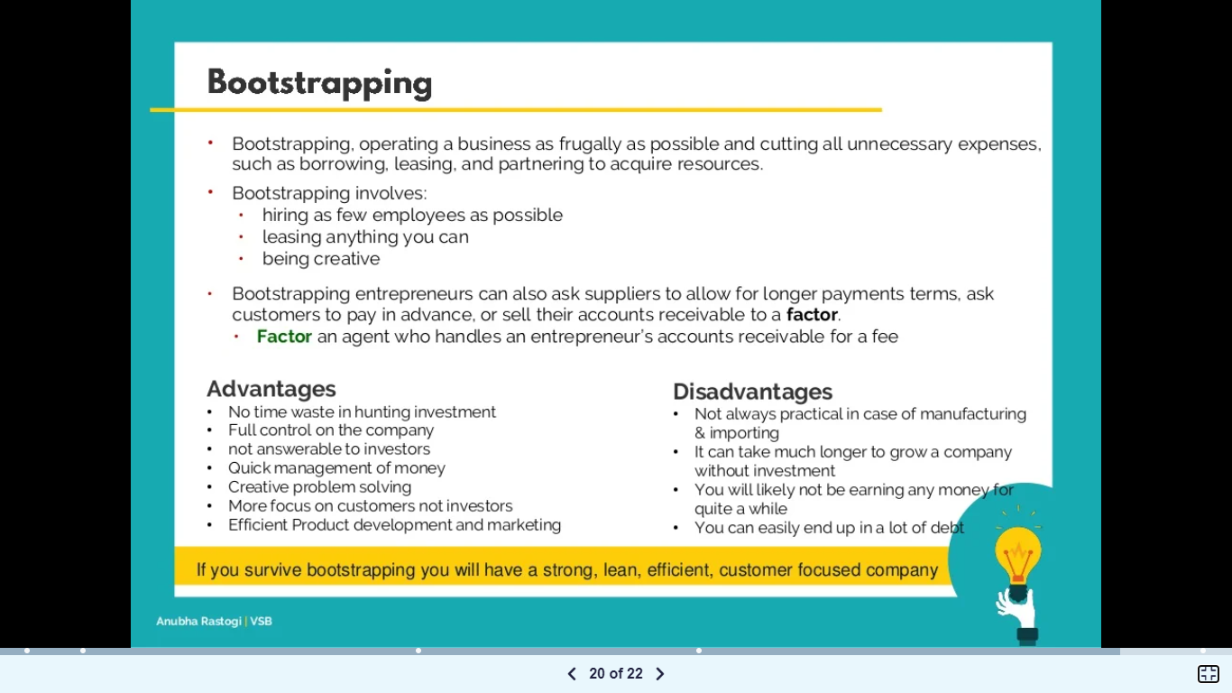

1. **Accounting Basics for Entrepreneurs**

Although financing and accounting complement and rely on each other, they are distinct. As we have seen, financing is the process of raising money. **Accounting** is the system of recording and classifying financial transactions related to a business, and summarizing and communicating those transactions in the form of financial statements. Accounting is essentially documenting what happens to money once a company receives it and thereby makes that information available for reporting to stakeholders and regulatory agencies, and informing business decisions.

At the most fundamental level, an accounting system accomplishes two goals:

1. It summarizes a business’s financial performance
2. It communicates that performance to owners, managers, and outside parties

The most common approach to accounting used in the United States, and around the world, follows the basic formula shown in Figure 9.6.

This formula is referred to as the basic **accounting equation**. First, we’ll define each of these terms, and then we’ll look at an example of a simple transaction recorded using the equation.

* **Assets** are items—such as equipment, cash, supplies, inventory, receivables, buildings, and vehicles—that a business owns and derives future use from. Potential investors want to know what resources a company has at its disposal. Business owners want to see where their money has gone. Let’s return to the case of Shanti, the website designer who starts her business by purchasing a new laptop computer. The computer is an asset that Shanti has acquired for her business.
* A **liability** is a debt that a company has incurred with another party, as when it borrows money from a bank or purchases materials from other suppliers. The business is required to make a future payment to satisfy that debt. For accounting purposes, we want to be able to see what the business owns (assets) compared with what it owes (liabilities).
* **Equity** is the owner’s claim on the assets of the business, that is, the difference between what they own and what they owe. Essentially, equity tells a business owner or investor how much the firm is worth after all the debt is repaid. Returning to the example of Shanti’s website design business, let’s compare two scenarios of startup purchases to see the effects on the accounting equation. In both cases, Shanti contributes some of her own money to the initial purchase of a laptop.



In the first scenario, shown in [Figure 9.7](https://openstax.org/books/entrepreneurship/pages/9-3-accounting-basics-for-entrepreneurs#OSX_Eship_09_03_Equity01), she contributes $1,000 to the new business.

Each element of the accounting equation has its own account in an accounting system or software package, and all changes are tracked within its account. The accounting equation must stay in balance after every transaction with assets equaling liabilities. In this case, Cash is an assets account, and Owner’s Capital is an equity account. The $1,000 cash contributed is a cash asset and becomes equity that is recorded as owner’s capital. At this point, Shanti can claim 100 percent of the assets of the business, which right now consist only of the cash.

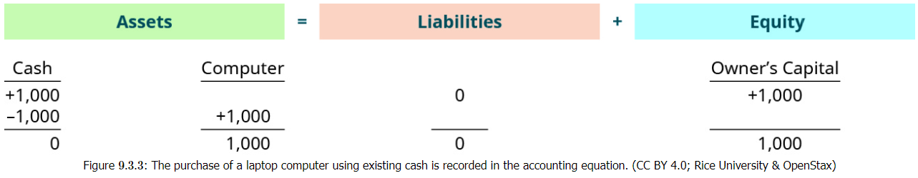If she uses all of her cash assets to purchase the laptop, the accounting equation will record this as shown in Figure 9.8.

When the cash is spent, reducing the assets column to zero, a new asset account for the computer is created to record the dollar amount paid for the laptop. Again, because Shanti doesn’t owe another party at the end of the transaction (because she didn’t make any additional contribution), the balance of the owner’s equity account remains the same. The equation shows that Shanti still owns 100 percent of the assets.

Now consider how to account for a situation in which Shanti does not have a significant amount of cash to contribute to the business. She can afford to contribute only $100 and deposits the money into the business’s bank account. Fortunately, she also has access to a credit card that can be charged for business purchases, increasing her investment options.

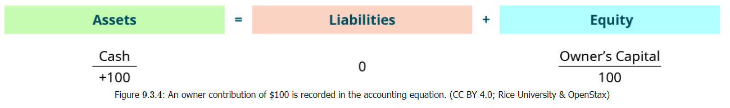The initial contribution to the business is recorded in the same way but with the new amount, as shown in Figure 9.9.

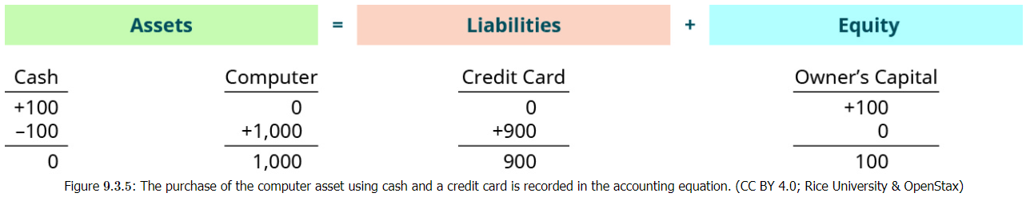The laptop still costs $1,000, but the business has only $100 in cash assets. Shanti purchases the laptop with a credit card, and the clerk finalizes the sale. Figure 9.10 shows the impact of the sale on the accounting equation.

In both examples, Shanti reports the computer as an asset of the business that is valued at its $1,000 cost. In the first scenario, she exchanged the cash for the computer. In the second, she exchanged a smaller amount of cash for the laptop and charged the remaining amount of the purchase on a credit card. This creates a liability for the business that Shanti will need to repay in the future. Since this is an equation, both sides must be equal to each other, and this proves to be the case in both scenarios. The total assets are $1,000, and the total liabilities plus equity are also $1,000.

**What are the Benefits of Accounting for Entrepreneurs?**

As an entrepreneur, proper accounting can help you better understand your business’s financial health and make informed decisions about your company’s finances. Here are some of the main benefits of proper accounting techniques for entrepreneurs:

**1. Budget for Expenses**

Accounting can help entrepreneurs create and manage detailed budgets for their businesses. When you understand how much money is coming into and going out of your business, you’re better equipped to plan for your expenses.

**2. Improve Efficiency**

With a proper accounting system in place, entrepreneurs can forecast revenues for their businesses. You’ll be able to see how efficiently your company generates revenue from your expenses. With that information, you can evaluate your marketing efforts to invest in campaigns that drive revenue and abandon those that don’t.

**3. Simplify Tax Season**

Accounting helps entrepreneurs prepare for tax season, to ease the headache of filing income taxes. With proper accounting and bookkeeping, you’ll have all the records of your business’s earnings and expenses filed away, which will make filing your income tax quicker and easier.

**4. Monitor Your Growth**

Accounting gives you a handle on your company’s assets and liabilities and how they change over time, which lets you monitor the growth of your business. You can understand what services are driving the most revenue in your business, which can help you adjust your business model to further grow your profits.

1. **Developing Startup Financial Statements and Projections**

You have learned how an accounting system classifies transactions in terms of assets, liabilities, and equity; what those transactions mean in terms of the accounting equation; and what that information says about an entity’s overall financial health. Now we’ll examine how to summarize those transactions in financial statements that can be shared with stakeholders. Internally, these statements are used to make decisions about the management of the company and its operations. Externally, they provide existing and potential investors with data to inform their financial support of the venture.

The information entered into the accounting system is summarized in financial statements, which are the output of an accounting system. We will examine three basic types of financial statements:

* The balance sheet
* The income statement
* The statement of cash flows

**Balance Sheet**

The first financial statement is the **balance sheet**. The balance sheet summarizes the accounting equation and organizes the different individual accounts into logical groupings. As you previously learned, the components of the accounting equation are:

* assets—items the company owns or will benefit from; examples include cash, inventory, and equipment
* liabilities—debt or amounts the company must repay in the future; examples include credit card balances, loans payable, and so on
* equity—the share of the assets due to the owners after debt is repaid

The accounting equation itself (assets = liabilities + equity) is spelled out on the balance sheet. It is shown in two portions. On one side, all of the assets are spelled out and their amounts totaled. This total is compared to the totals in the second and third portions, which show liabilities and equity. Just as the accounting equation itself must balance, so must the balance sheet.

**Income Statement**

The second basic **financial statemen**t is the income statement, which provides the results of a company’s operations. At the most basic level, the income statement—also called the **profit-and-loss statement**—describes how much money the company earned while operating the business and what costs it incurred while generating those revenues. An investor wants to know how much money the company brought in from customers and how much it had to spend to get those customers. Revenue minus expenses results in **net income**, or profit if there are funds left over.

**The Statement of Cash Flows**

The third basic financial statement we will discuss is the statement of cash flows, which explains the sources of and uses of a company’s cash.

You may wonder how the statement of cash flows differs from an income statement. The short answer is that the income statement captures events as they happen, not necessarily when the company gets paid. It records certain items, such as sales, when the work is completed. Let’s return to Shanti, the website designer. As soon as she completes the client’s website, the accounting system will record the revenue, the amount that is due from that client; this second item is referred to as accounts receivable. If Shanti’s client is struggling financially or even goes out of business, she may never get paid for that work, but the income statement would show sales, and therefore possibly a profit. If the customer goes out of business, the business bank account will not have any evidence of a profit.

**What is a financial projection?**

In short, financial projections are a forecast of future revenue and expenses. Generally, financial projections account for historical data, while also including a prediction for external market factors. You can create different types of financial projections for startups, including short-term, medium-term, and long-term projections. While short-term projections tend to be focused on the first year of your business, a long-term projection may cover three to five years.

**Why are financial projections important?**

Financial projections are important for a variety of reasons. Usually, they’re used to attract investors or apply for a bank loan. However, learning how to make financial projections for small business can also have a range of benefits for your business. It enables you to reevaluate your business’s strengths and weaknesses, anticipate problems, take stock of your current position, and establish a clear course of action to generate growth. It’s not just a number-crunching exercise, but a significant element of your company’s long-term strategic planning, helping to translate goals into clearly defined targets.

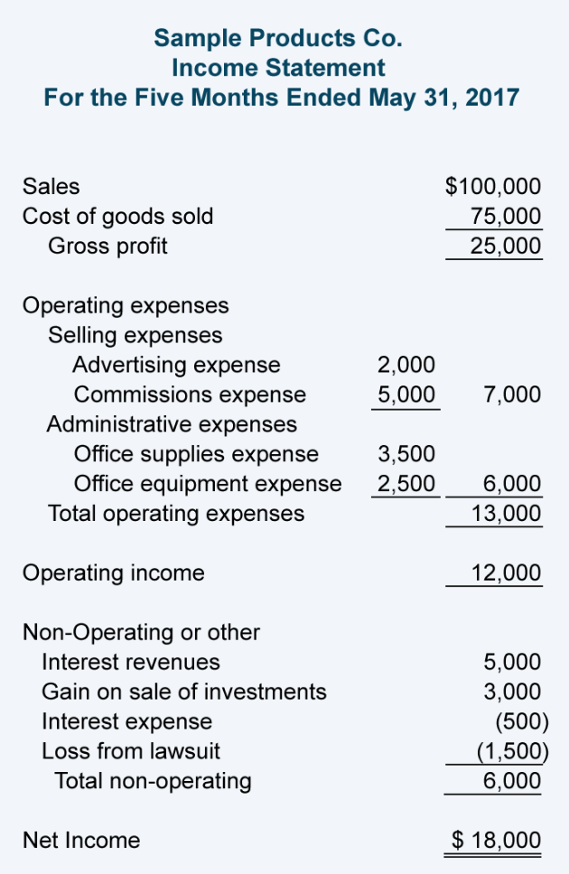

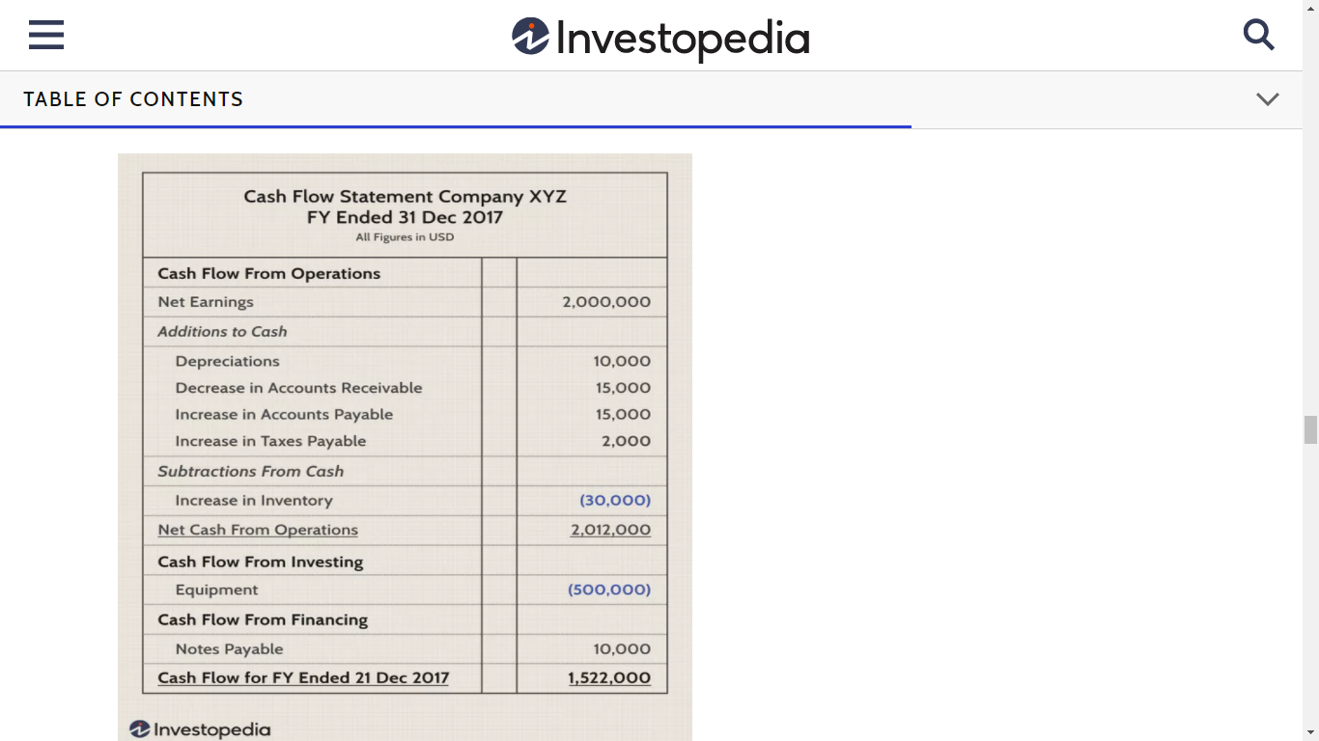

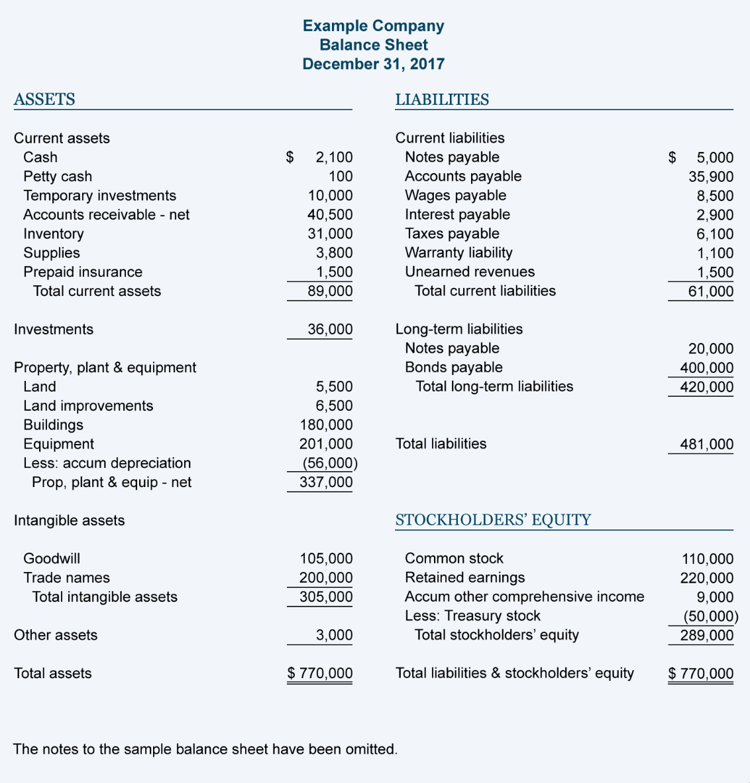

**SAMPLE BALANCE**

**SHEET**

**SAMPLE CASHFLOW STATEMENT**

**SAMPLE INCOME STATEMENT**

**SUMMARY**

**Overview of Entrepreneurial Finance and Accounting Strategies**

Entrepreneurial financing is concerned with understanding the funding requirements for a new business and what sources of funds are available. Each source comes with different expectations and requirements. Equity financing provides the entrepreneur with maximum flexibility: Dividends are not required and can be made when cash flow is strong enough to meet all obligations of the firm. Debt financing restricts financial flexibility but can be cheaper under some circumstances. For example, SBA loans can be subsidized by the federal government. Financing is not a one-size-fits-all procedure.

**Special Funding Strategies**

For nonprofit organizations, achieving a sustainable funding strategy requires hard work, creativity, and a delicate balance of financial resources. These types of organizations need to create programs that will interest patrons who are willing to pay for activities. They also rely on the generosity of their benefactors beyond simple patronage in the form of donations, and they vie for extremely competitive grant funding.

Although loans and liabilities such as credit card debt can fund a new business, the repayment and additional interest charges are a real challenge to many entrepreneurs. Financing strategies that avoid loans, such as crowdfunding websites and bartering, offer opportunities for funding that are often more manageable.

Bootstrapping is the process of self-funding a startup business. Sometimes entrepreneurs will have no financial resources beyond their personal savings. This method of funding a business requires creative approaches to problem solving, generating business, and managing expenses. It can be a slower, more difficult process than a company with more funding might face, but in the long run, it can benefit the company’s strength and growth, and provide robust dividends to the founders.

**Accounting Basics for Entrepreneurs**

Accounting is concerned with how transactions are recorded in a way that helps entrepreneurs share information with stakeholders, including potential investors, and helps business owners make decisions about running their company.

**Developing Startup Financial Statements and Projections**

Entrepreneurs can use financial information for multiple purposes. These projections can help plan a new business. By forecasting the income and expenses of the first year, an entrepreneur can have a reasonable idea of the level of financing that may be required. Second, these projections can also show potential investors what the business will look like in the future and how long it might take them to get a return on their investment. Break-even points help illustrate a minimum amount of sales to cover expenses.

**REFERENCES:**

Introduction

1. <https://www.slideshare.net/AnubhaRastogi/introduction-to-entrepreneurial-finance>
2. <https://www.cliffsnotes.com/study-guides/accounting/accounting-principles-i/principles-of-accounting/introduction-to-accounting#:~:text=Accounting%20is%20the%20language%20of,the%20success%20of%20every%20business>
3. <https://www.thehartford.com/business-insurance/strategy/business-financing/equity-financing>
4. <https://www.thehartford.com/business-insurance/strategy/business-financing/debt-financing>

Overview of Entrepreneurial Finance and Accounting Strategies

1. <https://biz.libretexts.org/Bookshelves/Business/Entrepreneurship/Book%3A_Entrepreneurship_(OpenStax)/09%3A_Entrepreneurial_Finance_and_Accounting/9.01%3A_Overview_of_Entrepreneurial_Finance_and_Accounting_Strategies>
2. <https://www.forbes.com/sites/forbesbusinesscouncil/2021/07/09/five-essential-finance-and-accounting-strategies-for-small-businesses/?sh=3d8b2cf23e46>
3. <https://www.europeanbusinessreview.com/5-must-know-finance-and-accounting-strategies-for-small-businesses-during-uncertain-times/>

Special Funding Strategies

1. <https://biz.libretexts.org/Bookshelves/Business/Entrepreneurship/Book%3A_Entrepreneurship_(OpenStax)/09%3A_Entrepreneurial_Finance_and_Accounting/9.02%3A_Special_Funding_Strategies>
2. <https://www.slideshare.net/AnubhaRastogi/introduction-to-entrepreneurial-finance>
3. <https://www.cpp.edu/siil/events/startup-competitions.shtml>

<https://www.productmarketingalliance.com/the-importance-of-a-strong-pre-order-sales-strategy/>

Accounting Basics for Entrepreneurs

1. <https://biz.libretexts.org/Bookshelves/Business/Entrepreneurship/Book%3A_Entrepreneurship_(OpenStax)/09%3A_Entrepreneurial_Finance_and_Accounting/9.03%3A_Accounting_Basics_for_Entrepreneurs>
2. <https://www.freshbooks.com/hub/accounting/accounting-entrepreneurs>

Developing Startup Financial Statements and Projections

1. <https://biz.libretexts.org/Bookshelves/Business/Entrepreneurship/Book%3A_Entrepreneurship_(OpenStax)/09%3A_Entrepreneurial_Finance_and_Accounting/9.04%3A_Developing_Startup_Financial_Statements_and_Projections>
2. <https://www.freshbooks.com/hub/reports/sample-balance-sheet-and-income-statement-small-business>
3. <https://gocardless.com/en-us/guides/posts/financial-projections-for-startups/>
4. <https://www.investopedia.com/terms/f/financial-statements.asp>
5. <https://www.investopedia.com/investing/what-is-a-cash-flow-statement/>